## Role of the jet streams in the polar latitudes

### 1. Introduction and rationale

Over the last two decades the polar regions of the globe experienced large shifts in climate. Temperature in the Arctic has been increasing at about twice the rate of the global average and referred to as Arctic amplification (AA). The accelerated rate of Arctic sea ice loss and AA in recent decades (Stroeve et al 2012) has motivated numerous research on its potential consequences on the mid-latitude climate (Cohen et al 2014, Vihma 2014, Walsh 2014). For example, Francis et al. (2009), Overland and Wang (2010) and Francis and Vavrus (2012) emphasised the importance of the increase of the 1,000–500 hPa layer thickness over the Arctic and the consequent decrease in the north–south gradient in the thickness field. This leads to a weaker mid-latitude westerly flow, and thereby increased meanderings of the jet stream and extreme events, including cold outbreaks and snowfall in winter (Francis and Vavrus, 2012). Liu et al. (2012) also pointed out that the autumnal sea ice decline lead to broader meridional meanders in mid-latitudes during winter and increase in the frequency of occurrence of strong weather events, such as snow storms and cold-air outbreaks.

Shifts of the jet streams are the dominant source of variability in weather patterns across much of the midlatitudes (e.g., Hurrell and Deser 2009) and changes to its location have got a lot of attention in the literature. The weakening of the jet stream followed by amplification of wave anomalies suggested by Francis and Vavrus (2012) has not been supported by by observational (Barnes 2013, Barnes and Screen 2015), theoretical (Hoskins and Woollings 2015), or modeling studies (Hassanzadeh et al. 2014; Cattiaux et al. 2016; Sellevold et al. 2016). To date, no consistent response of regional temperature and extreme weather in mid-latitudes has emerged, with studies showing both cooling and warming of mid-latitude continents with reduced Arctic sea ice (see Vihma 2014 for more discussion).

Nevertheless, understanding the variability and change of the jet stream behaviour in the recent and future climate might help link the AA and weather in the mid-latitudes due to exceptional significance of the jets from dynamical and theoretical standpoint. There role was neatly summarised by Koch et al. (2006): first, the jet signifies the existence of an underlying band of enhanced baroclinicity and, hence, of available potential energy and the possible seat of cyclonic development. Second, in the extratropics, the along-flow variation of a jet’s strength and direction, in particular, at jet entrance and exit regions, have been dynamically linked to, and are a seminal precursor sign for, surface cyclogenesis and anticyclogenesis. Third, the jet is dynamically linked to, and is an observational surrogate for, the co- aligned band of a strong potential vorticity (PV) gradient on the *in situ* isentropes. There are indications that a time-mean structure of the band influences the quasi-horizontal propagation of both stationary large-scale Rossby waves (see e.g. Hoskins and Ambrizzi, 1993, Massacand and Davies, 2001) and its more transient features exert a profound effect upon and reflects the presence of synoptic-scale waves (Nakamura and Sampe, 2002 Schwierz *et al*., 2004).

Jet shifts are associated with altered storm-track paths and with changes in the regions that experience a mild oceanic or cross-latitude influence. Woolings et al. (2018) analyse multidecadal jet variability and propose a barotropic mechanism to explain its north-south displacement. They suggest that in case of a stronger jet a meridional asymmetry in the distribution of wave breaking develops, with most breaking occurring on the equatorward flank of the jet and very little on the poleward flank. This leads to a small variability in jet latitude. On the other hand, when the jet is weak, wave breaking occurs on both poleward and equatorard sides of it, leading to strong variability in jet latitude.

Jet streams are often identified using a wind speed threshold that defines the body of a jet stream (e.g., Koch et al. 2006; Strong and Davis 2007). As noted by Spensbernger et al. (2017) such identification schemes then detect large coherent areas as one jet body that may have multiple wind speed maxima within one body. For example, in the winter snapshots in Figs. 2b and 2c of Koch et al. (2006), almost all visible wind maxima are encompassed by only one jet body that covers considerable parts of midlatitudes in the Northern Hemisphere. To alleviate this problem, several algorithms have been developed during the last decades to objectively identify the *axis* of jet streams, i.e. the maximum of wind speed within the jet (e.g., Woollings et al. 2010, Spensbernger et al. 2017). However, polar regions, which are focus of this paper, are characterised by lower wind speeds and less frequent jet streams. The latter can be noticed in all jet climatologies, either axis-based (Woollings et al. 2010, Spensbernger et al. 2017) or those that define jets using wind threshold allowing larger areas being considered as jet streams (Koch et al. 2006, Limbich et al. 2012). More importantly, as can be seen in Figs. 2b and 2c of Koch et al. (2006), jets in high latitudes tend not to cover large areas, but are rather spatially confined elongated structures. This is particularly important for our analysis allowing jet identification in high latitudes using a single parameter based on a wind speed threshold.

Why we are interested in small and relatively slow jets found in polar regions? Schwierz et al. (2004) showed that upper-tropospheric jet streams can act as a waveguide and a seat for trapped Rossby waves. However, Rossby waves are usually discussed in relation to subtropics and mid-latitudes. As shown by Hoskins and Karoly (1981), changes in the propagation of Rossby waves can be understood using the stationary wavenumber, defined as

*Ks* = …(1)

Here *f* is the latitude, *u* is the westerly zonal wind speed, with [ ] denoting a sector zonal average, and c is the wave phase speed. The term *b\** is the meridional gradient of absolute vorticity on the sphere, given by

*b* = 2 omega cos(f)/a - … (2)*

where *omega* and *a* are the angular velocity and radius of Earth, respectively. In high latitudes *b\** tends to zero (see, for example, Fig. 7 of Freitas and Rao, 2014), leading to low Ks values which causes Rossby waves to turn equatorward as Ks reaches critical value. However, in the vicinity of jet streams, the second term in (2) gets more weight due to a larger gradient in the wind speed resulting in increase of Ks values and allowing Rossby wave propagation within high latitudes.

Although the above theory is developed assuming zonally symmetric conditions that vary slowly relative to the scale of the wave, we allow for zonal variations of the mean zonal flow in (1) and (2) following Hoskins and Ambrizzi (1993), Li et al. (2015a, b) and Macintosh and Hendon (2017). This is partly justified because the mean flow is organised into jets so that the zonal gradients in the mean absolute vorticity are typically small compared to the scale of the waves and compared to the meridional gradient of mean absolute vorticity (e.g., Li et al. 2015a, b).

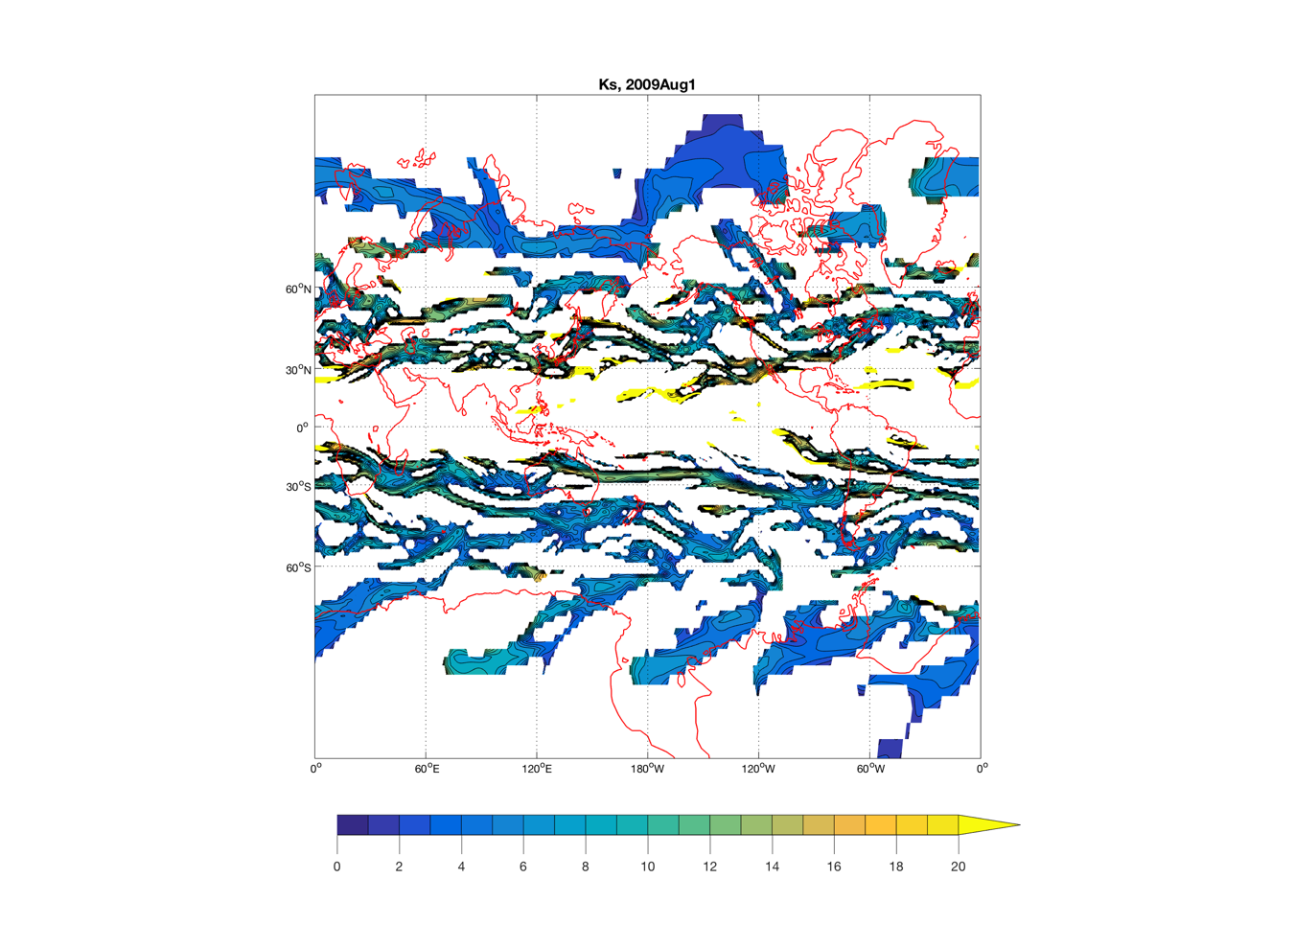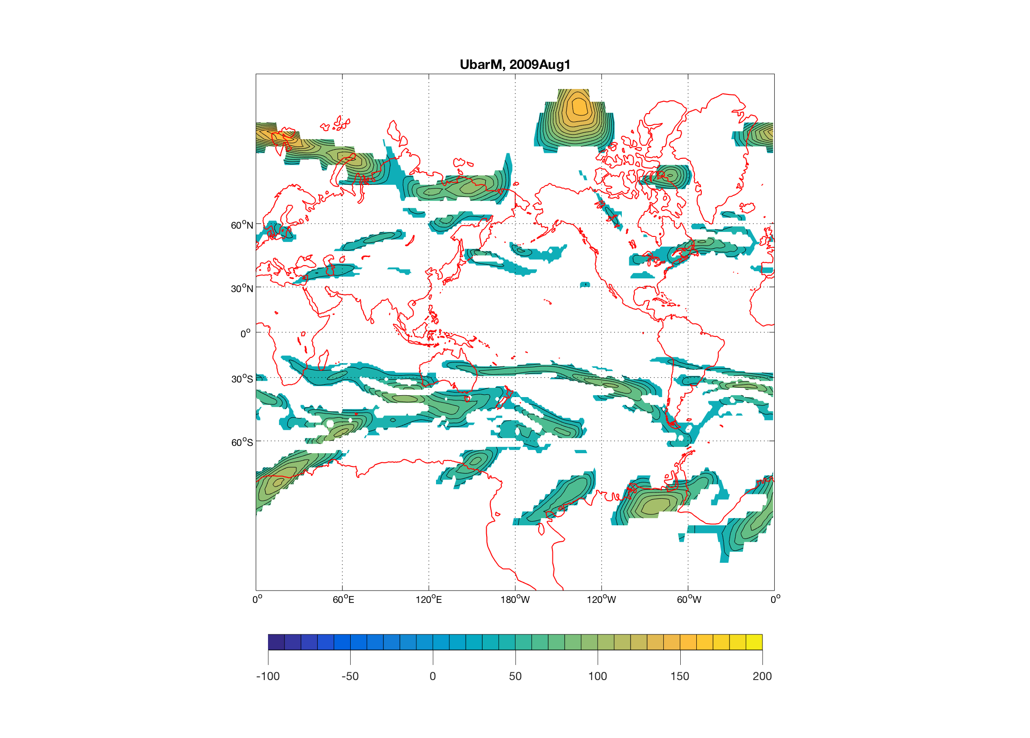

**Fig. 1.** *Zonal wind overlaid with Ks values at 00 UTC 1 Aug 2009 (should be one plot in polar projection)*

Figure 1 illustrates an instantaneous distribution of jet streams and corresponding Ks values. It reveals a complex of jets in various latitudes. As discussed earlier, … a few well defined jets at high lat ….. …. a good correspondence between the location of jet streams and Ks … (plot the figure and describe it)

Figure 1 supports the suggestion that jet streams in the polar regions act as waveguides and thus are of particular importance in time of changing climate. Our objective in this study is to derive a climatology of jets in the polar regions (Section 3) and finding the modes of jet variability in high latitudes (Section 4). Thereafter (Section 5), a comparison of the derived mode variability is made with that for other other variable variables, such as temperature anomalies, and inferences concerning dynamical implications are drawn.

### 2. Data and methods

The dataset used in this study is the ERA-Interim reanalysis (Dee *et al.,* 2011) from the European Centre for Medium-Range Weather Forecasts (ECMWF) with a horizontal grid spacing of 1◦ . We focus on … *September/March/JJA* …. from 1979 to 2017. The following 6-hourly variables are used: geopotential height at 300 hPa (*Z300*), mean sea level pressure (SLP), pzonal (*U* ) and meridional (*V* ) wind components, 2m temperature (*T2m*).

*2.1. Frequency of jets*

Jets are defined at a given grid point when the wind at 300 hPa exceeds XX m/s (*22 m/s currently*). As mentioned in the Introduction this simple approach is justified by low frequency of jet events in the high latitudes latitudes and their confined elongated structure. The wind speed threshold was arbitrary selected after sensitivity experiments (not shown). The relatively low value of the threshold (XX m/s) is explained by lower wind speed in the high latitudes. This is confirmed by Figs. 4 and 12 of Woollongs et al. (2018), which shows that to the north of 600N the averaged wind speed is below 10-15 m/s, while intense jets almost never occur in that region.

Frequency of jets is the number of 6-hourly time steps when a jet was present at a given grid point within the selected month. Fig. 2 (or maybe called fig. 1b) shows an example of jet frequency for March 1987. It reveals the location of XX (2 or 3) jets during this months …(describe geographical location). What is important here is that monthly jet frequency still retains the information about location of individual jets which is not the case for annual or seasonal frequencies (not shown). Monthly timescale is also useful in the analysis of possible link between the jet location and the weather in mid-latitudes as it allows enough time for weather regimes to respond.

**Fig. 2.** Frequency of jets for March 1987.

*2.2. Cluster analysis*

…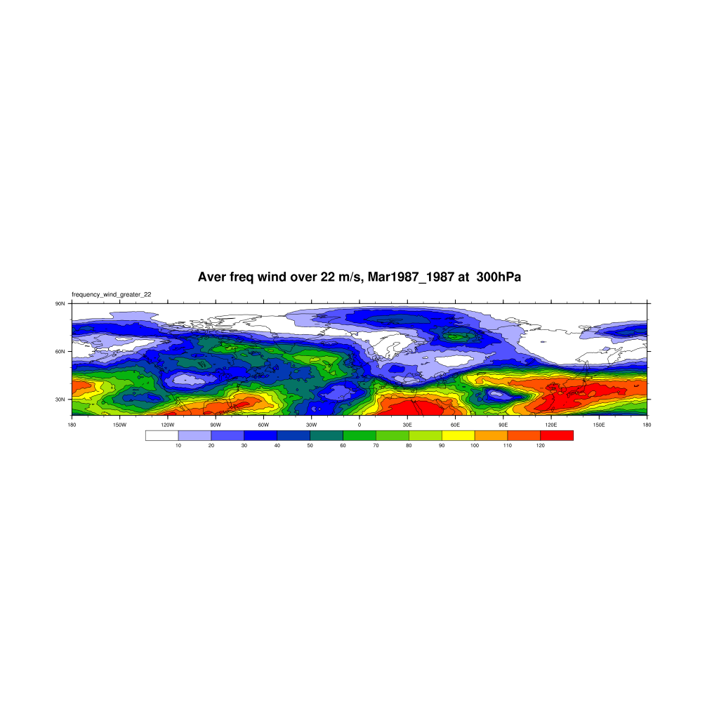

### 3. Climatology of jets in polar latitudes

Average frequency for selected months, trends

### 4. Jet clusters

Show clusters for selected months (Fig. X)

### 5. Relation to weather regimes and temperature anomalies

Composites of Z300, Mslp and T2m corresponding to each cluster (see example Figs. Y)

### 6. Discussion

**Fig. X.** Clusters of jet frequency to the north of 60N.

**Fig. Y.** Composi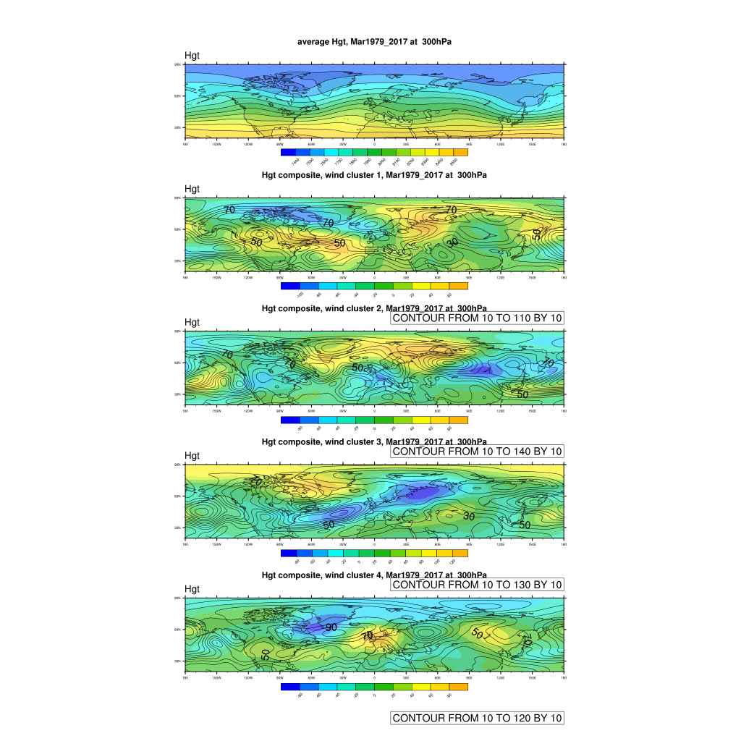tes of *Z300*.

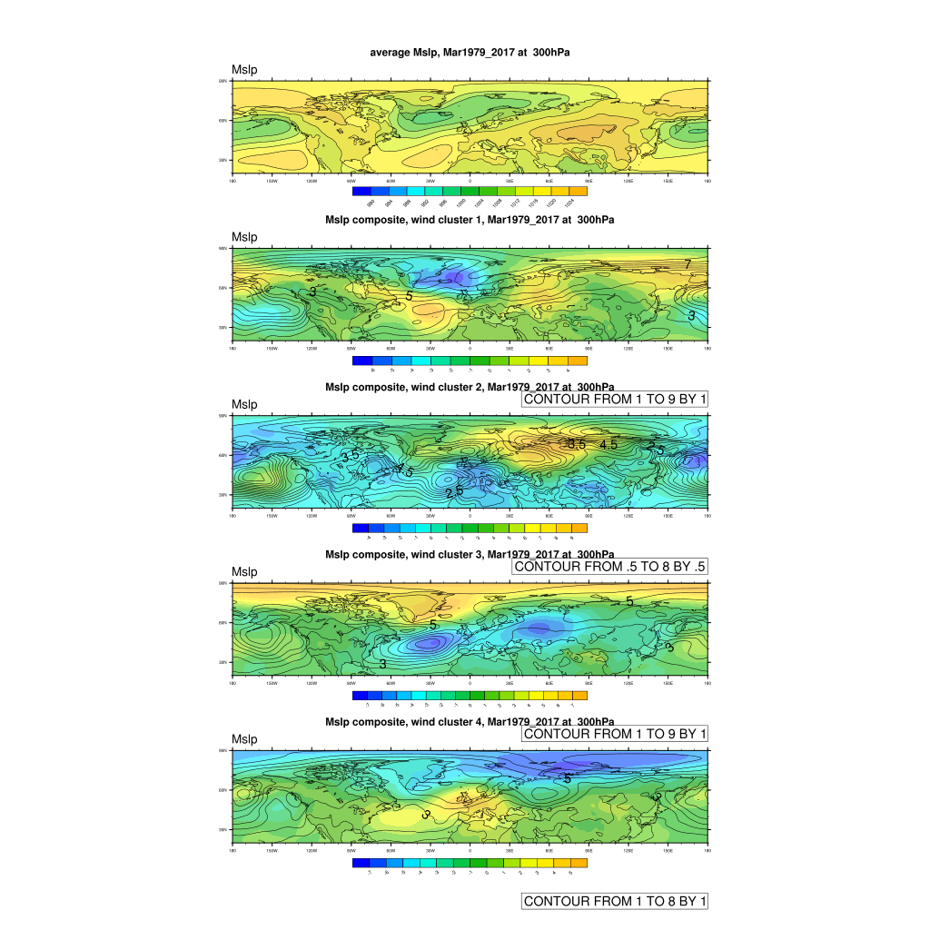

**Fig. Y.** Composites of *Mslp*.

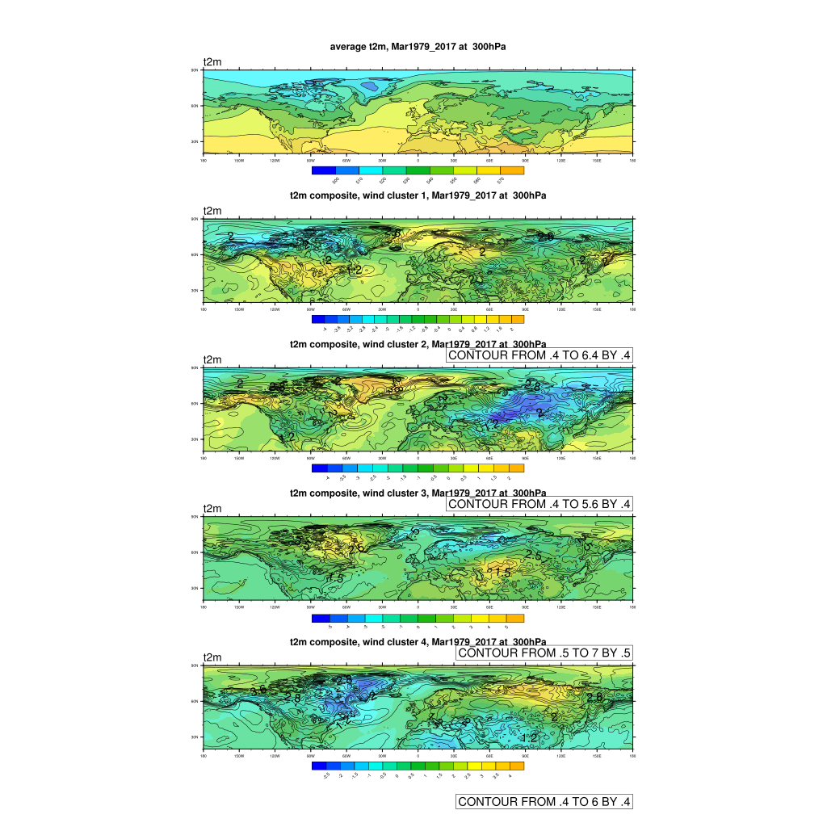

**Fig. Y.** Composites of *T2m*.

### References (not full list):

Ambrizzi T, Hoskins BJ, Hsu HH (1995) Rossby wave propagation and teleconnection patterns in the austral winter. J Atmos Sci 52:3661–3672

Freitas, A. C. and Rao, V. B. (2014), Global changes in propagation of stationary waves in a warming scenario. Q.J.R. Meteorol. Soc., 140: 364-383. doi:10.1002/qj.2151

Koch P, Wernli H, Davies HC. 2006. An event-based jet-stream climatology and typology. Int. J. Climatol. 26: 283–301. DOI: 10.1002/joc.1255.

Li Y, Lau N-C (2012) Impact of ENSO on the atmospheric variability over the North Atlantic in late winter—role of transient eddies. J Clim 25:320–342

Li X, Gerber EP, Holland DM, Yoo C (2015a) A Rossby wave bridge from the tropical Atlantic to West Antarctica. J Clim 28:2256–2273

Limbach S, Schomer E, Wernli H. 2012. Detection, tracking and event localization of jet stream features in 4-D atmospheric data. Geoscientific. Model Development 5: 457–470. DOI: 10.5194/gmd-5-457-2012.

Spensberger, C., T. Spengler, and C. Li, 2017: Upper-Tropospheric Jet Axis Detection and Application to the Boreal Winter 2013/14. Mon. Wea. Rev., 145, 2363–2374, https://doi.org/10.1175/MWR-D-16-0467.1

Stroeve J C et al 2012 Trends in Arctic sea ice extent from CMIP5, CMIP3 and observations Geophys. *Res. Lett.* **39** L16502. doi: <https://doi.org/10.1029/2012GL052868>

Schwierz, C., S. Dirren, and H.C. Davies, 2004: Forced Waves on a Zonally Aligned Jet Stream. J. Atmos. Sci., 61, 73–87, https://doi.org/10.1175/1520-0469(2004)061<0073:FWOAZA>2.0.CO;2

Woollings, T. , Hannachi, A. and Hoskins, B. (2010), Variability of the North Atlantic eddy‐driven jet stream. Q.J.R. Meteorol. Soc., 136: 856-868. doi:10.1002/qj.625

Yannick Peings et al 2018: Projected squeezing of the wintertime North-Atlantic jet. *Environ. Res. Lett.* **13** 074016. dos: https://doi.org/10.1088/1748-9326/aacc79